CSIS 3175 – 001

Members:

BOSCO YORK LI

TSZ WONG

KRISTY LE

Description:

Customers have emphasize the need for a search bar to search a location area in advance. Customers also requested for an option to choose what type of car they wanted for instances where they might have a big group of people or lugging items. As for Admins, they demanded for a way to track the amount of service it’s done in kilometres to determine if the vehicles needed maintenance.

Problems/Goals:

Auto Assist’s overall goal is to provide customers with an app that helps them locates vehicles near their desired location, in which they can rent a car to transport them to a destination. Users will be able to make requests through their personal accounts, where they can request a car or change their account details. Whereas Admins will have the ability to track all car locations and the users currently using the vehicles. Regarding the vehicles itself, Admins can inquire that all unused cars will be routed to specific lots and distributed evenly to ensure complete coverage across the city. The admin can also monitor the vehicles usage to determine if the vehicle requires servicing. However, if the vehicle reaches a set distance the car will be automatically sent to servicing and alert the admin of the status of the vehicle.

Diagrams:

ADMIN ACTIVITY DIAGRAM

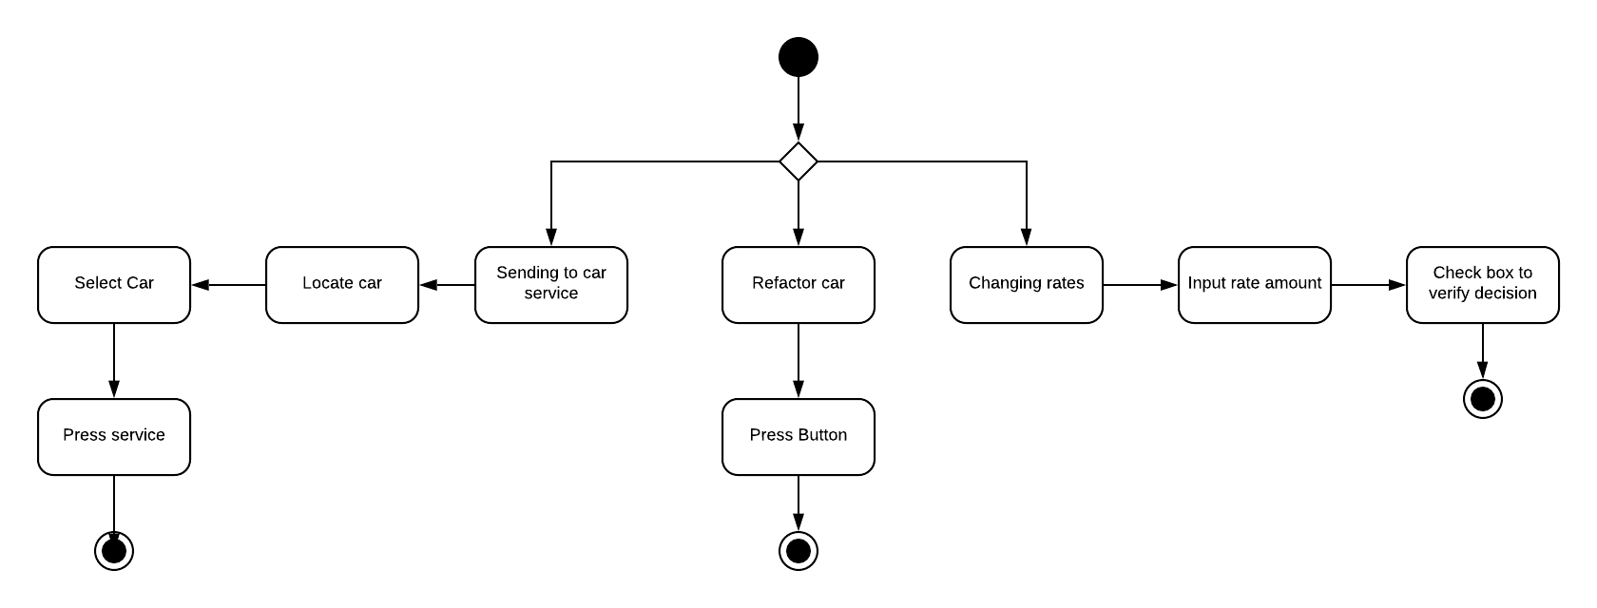

LOGIN ACTIVITY

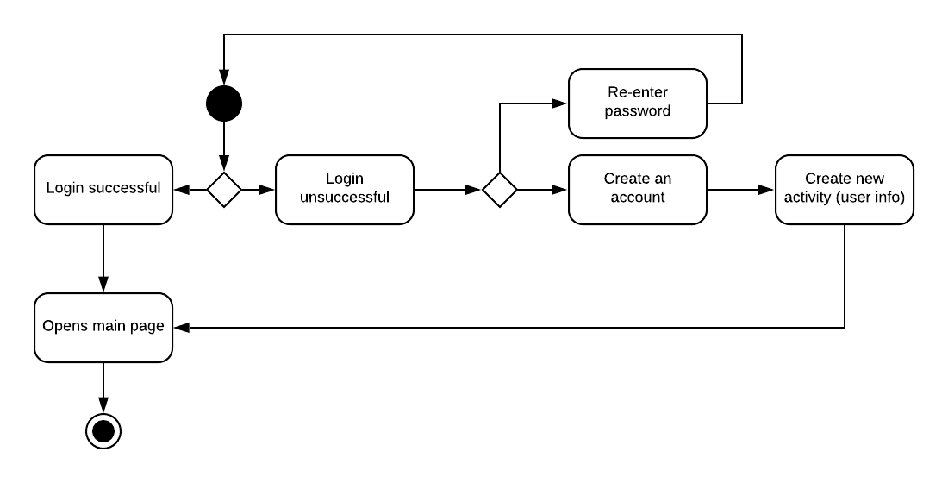

USER ACTIVITY DIAGRAM

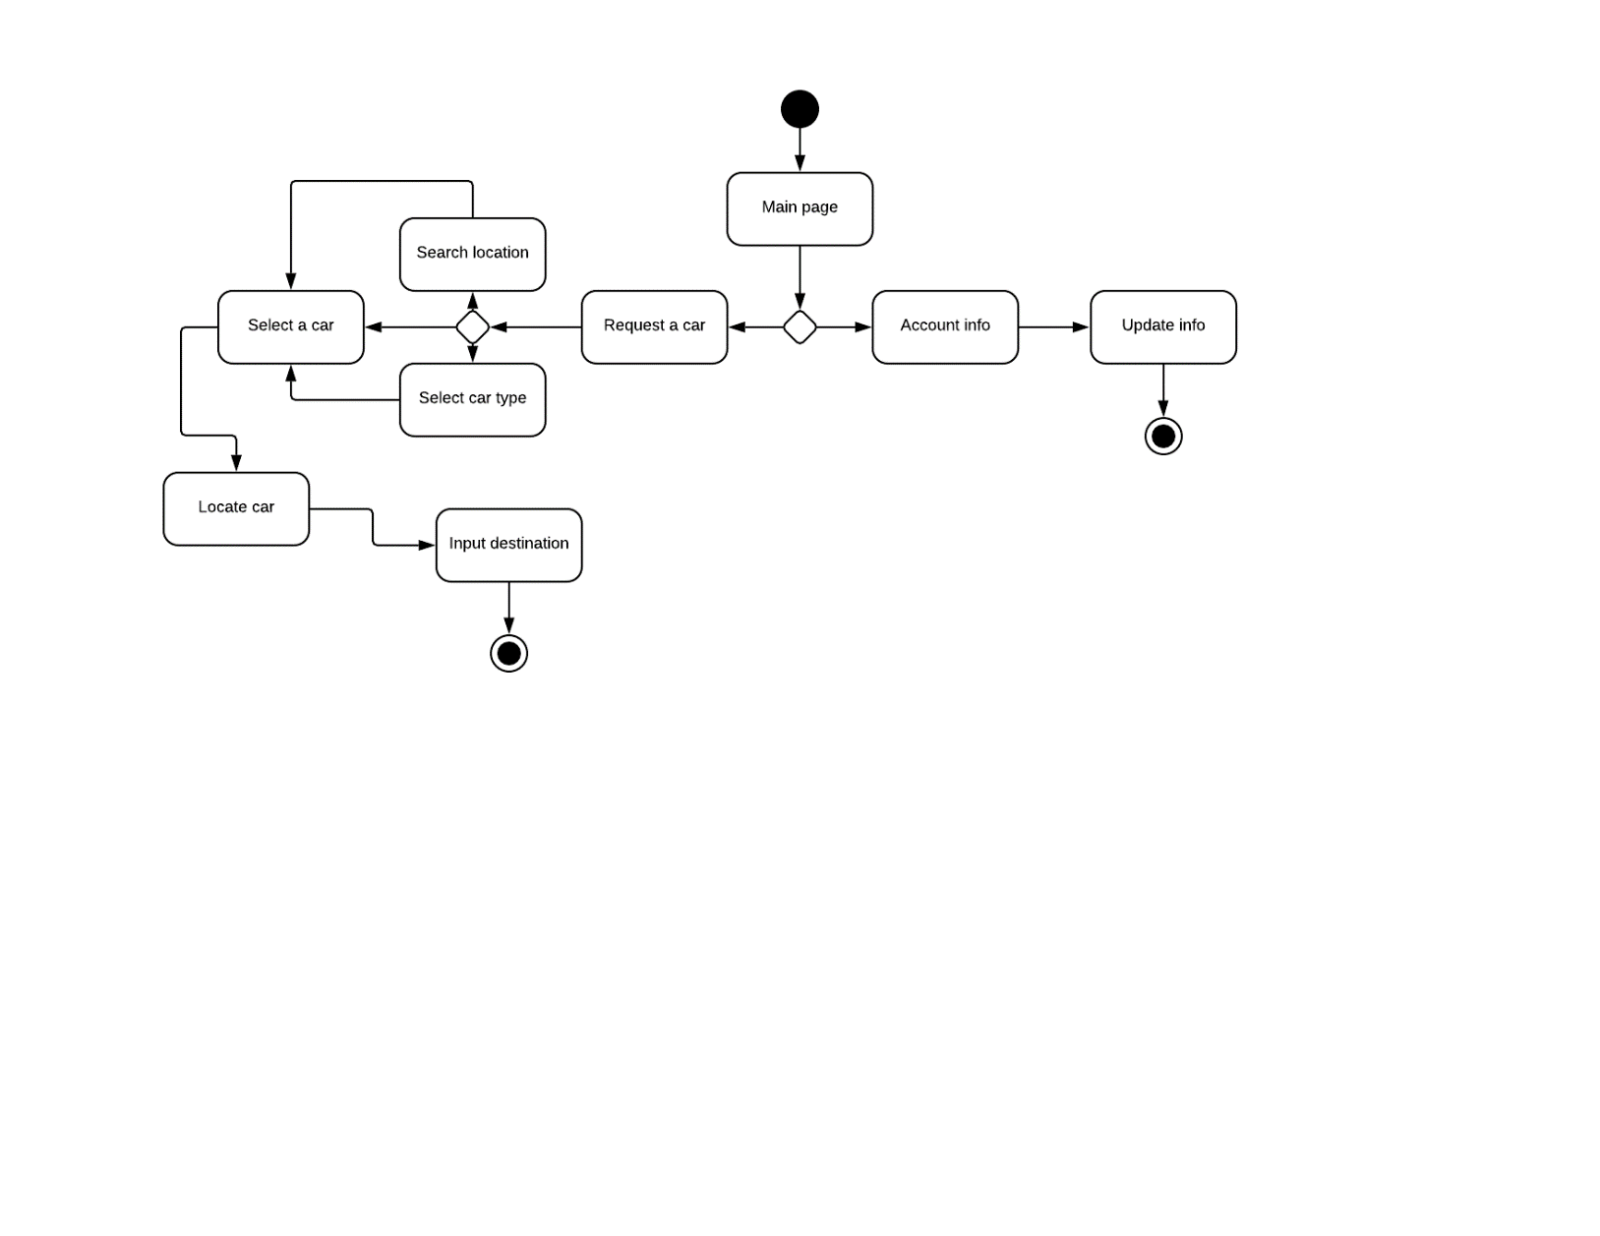

******

Marking Criteria:

1. Main page **[1 mark]**
   1. Navigation list
      1. Home
      2. My Account
2. User view **[3 marks]**
   1. User picks a car from the list [1 mark]
      1. Cars available near you list
      2. Drop down spinner
      3. Enter a specific location user would want to gain service from
   2. myAccount
      1. Payment
      2. Account info
   3. History
      1. Current/Previous transactions
   4. Google maps [2 marks]
      1. Display vehicle info
         1. How many seats
         2. Size of car
         3. ID, license plate
3. Admin view **[6 marks]**
   1. Admin controller
      1. Rates
      2. Data – overall finance of the day, active and running cars [2 marks]
      3. Redistribute cars [2 marks]
   2. Car list
      1. List all vehicles owned by the company
   3. Google maps [2 marks]
      1. Touches a specific location of a car
         1. Info of the car’s id
         2. License plate
         3. Gives options to:
            1. Deactivate car button
            2. Service car button
            3. Typing in an address to send car to a location